**Name:** Phani Kumar

**Batch:** June 01, 2022

**Tutor:** Raham Shaik

**Project: Integration of different tools with Jenkins**

**Project:**

1. Created EC2 instance for Jenkins server and installed java git and jenkins and created node and connected via ssh and conncet to jenkins server

]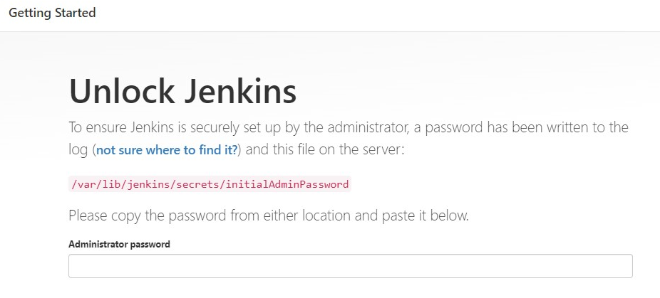

1. Created Node in Jenkins Webserver with the following steps
2. Manage Jenkins – Manage Nodes – Create New Node and given required details like Name, Credintials and then save

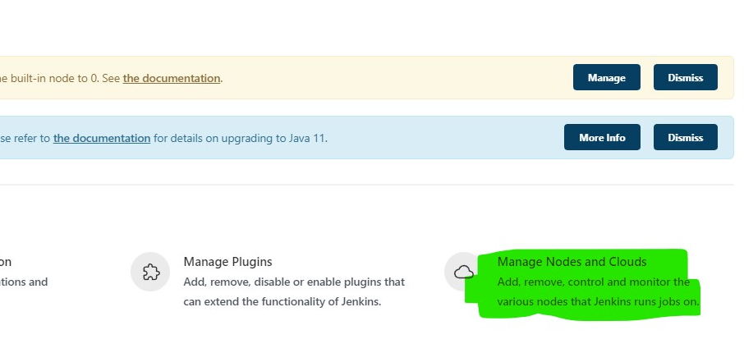

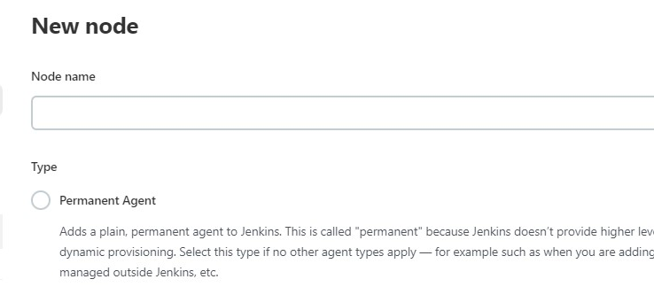

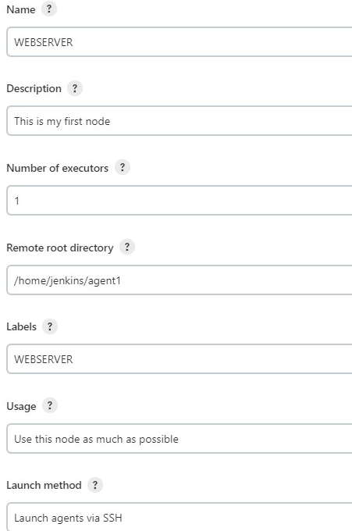

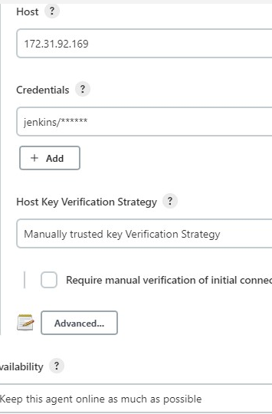

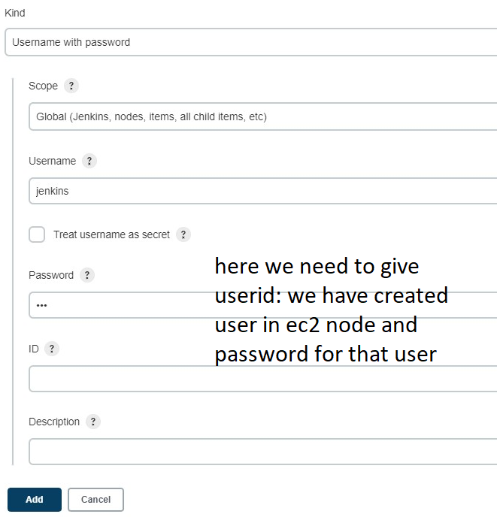

1. Then click on build
2. To Deploy a War File we need tomcat Server
3. Create Tomcat Server in Node, before installing tom cat we need to install Java in Node
4. Install Java by using following command

yum install java-1.8*

1. Then Install the tomcat by using Wget command
2. wget https://dlcdn.apache.org/tomcat/tomcat-8/v8.5.81/bin/apache-tomcat-8.5.81.tar.gz
3. Then mv apache-tomcat-8.5.81.tar.gz /opt
4. Then untar tomcat by using tar –zxvf apache-tomcat-8.5.81.tar.gz
5. Then went to conf directory
6. Then Provide Executable Permissions to Startup.sh & Shutdown.sh by using following command
7. chmod +x startup.sh & chmod +x shutdown.sh
8. Then connect local host i.e localhost:8080 (by default it will be 8080)

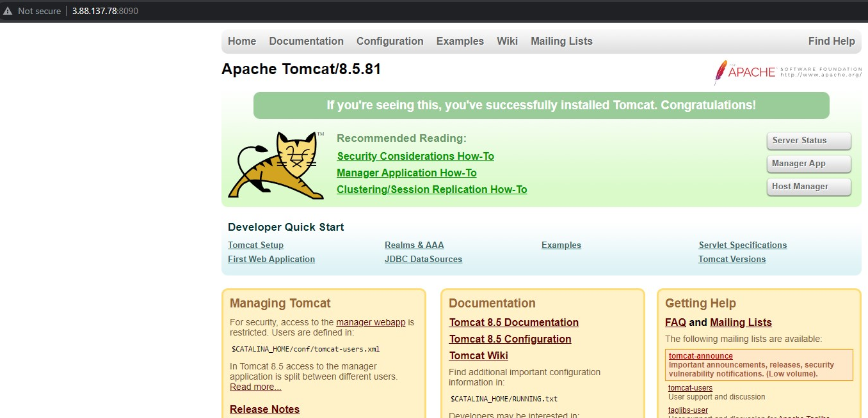

1. Roles added for executing the Server Status, Manager app & Host manager in tomcat-users.xml file

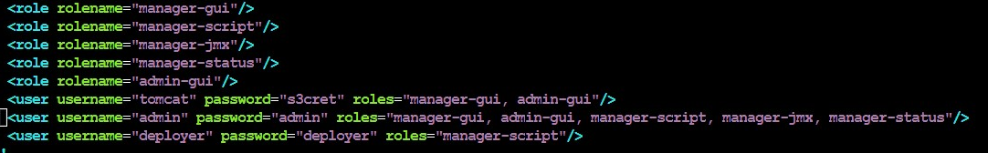

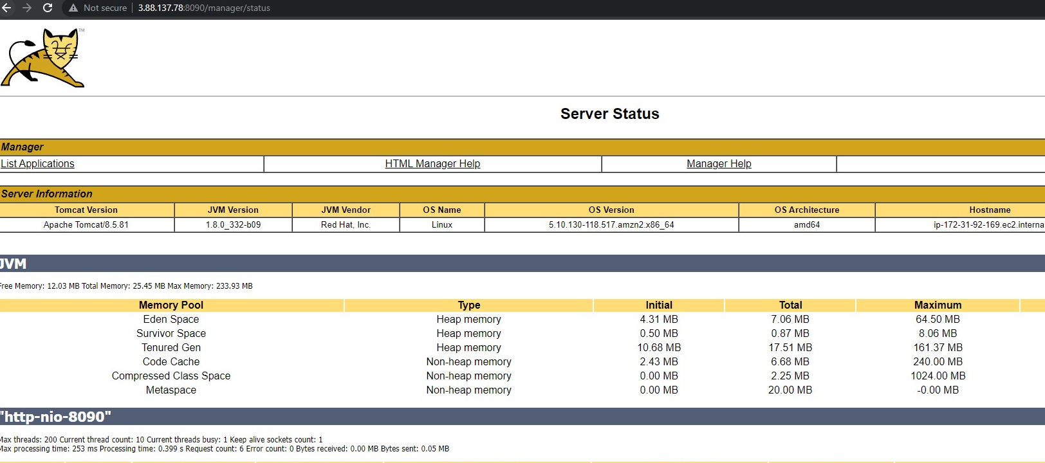

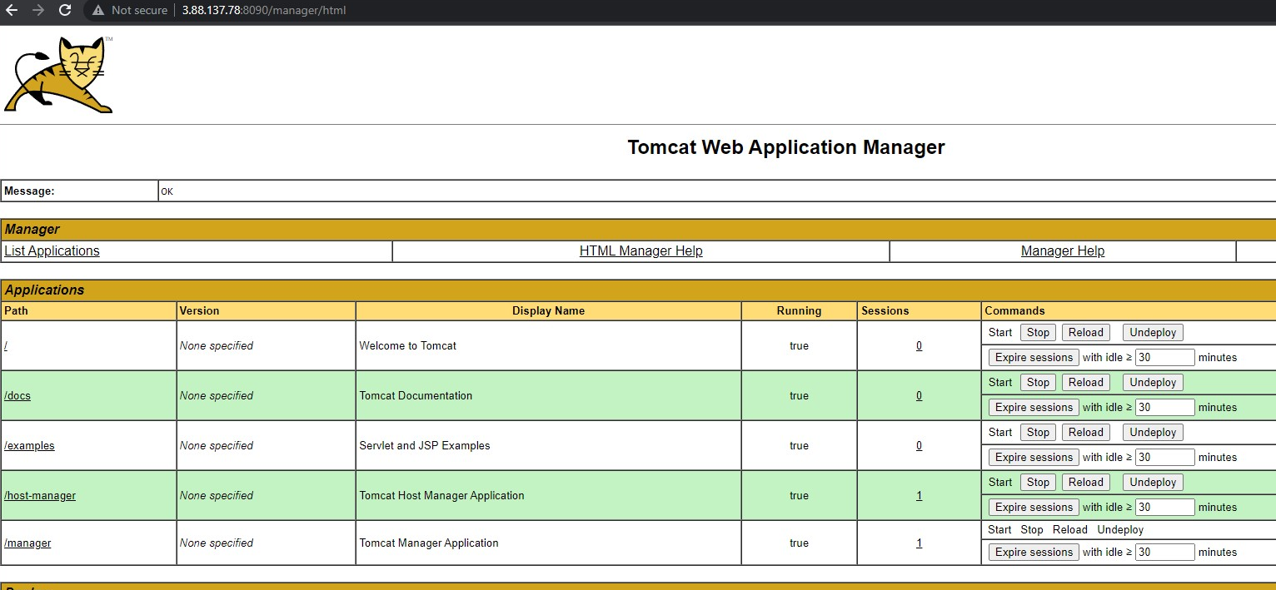

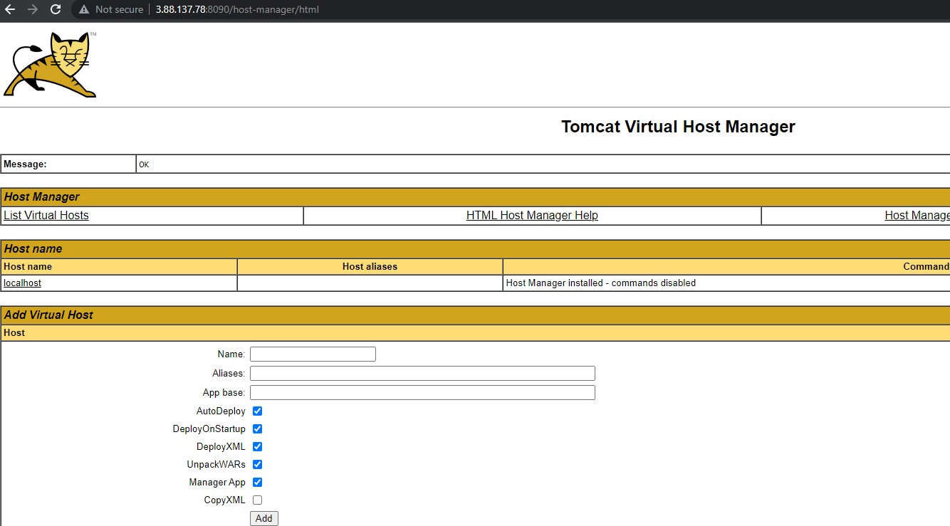

To Deploy a war file we need tomcat server

1. Created tomcat server and installed Java and tomcat server in that

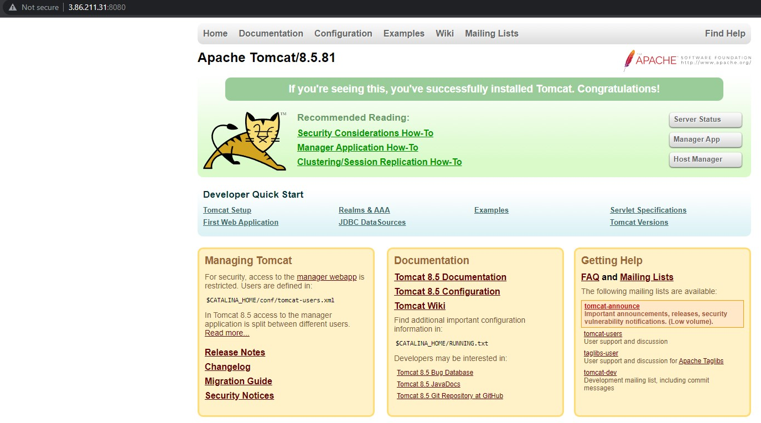

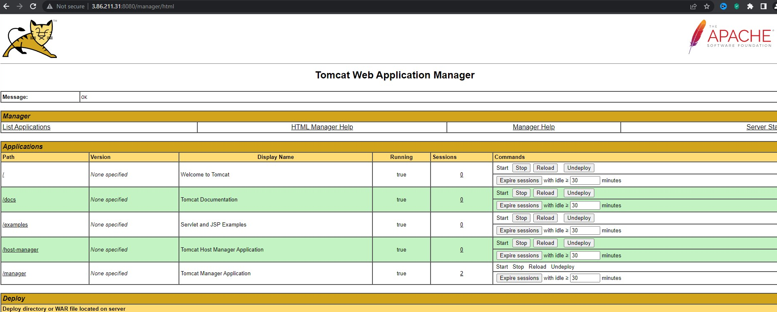



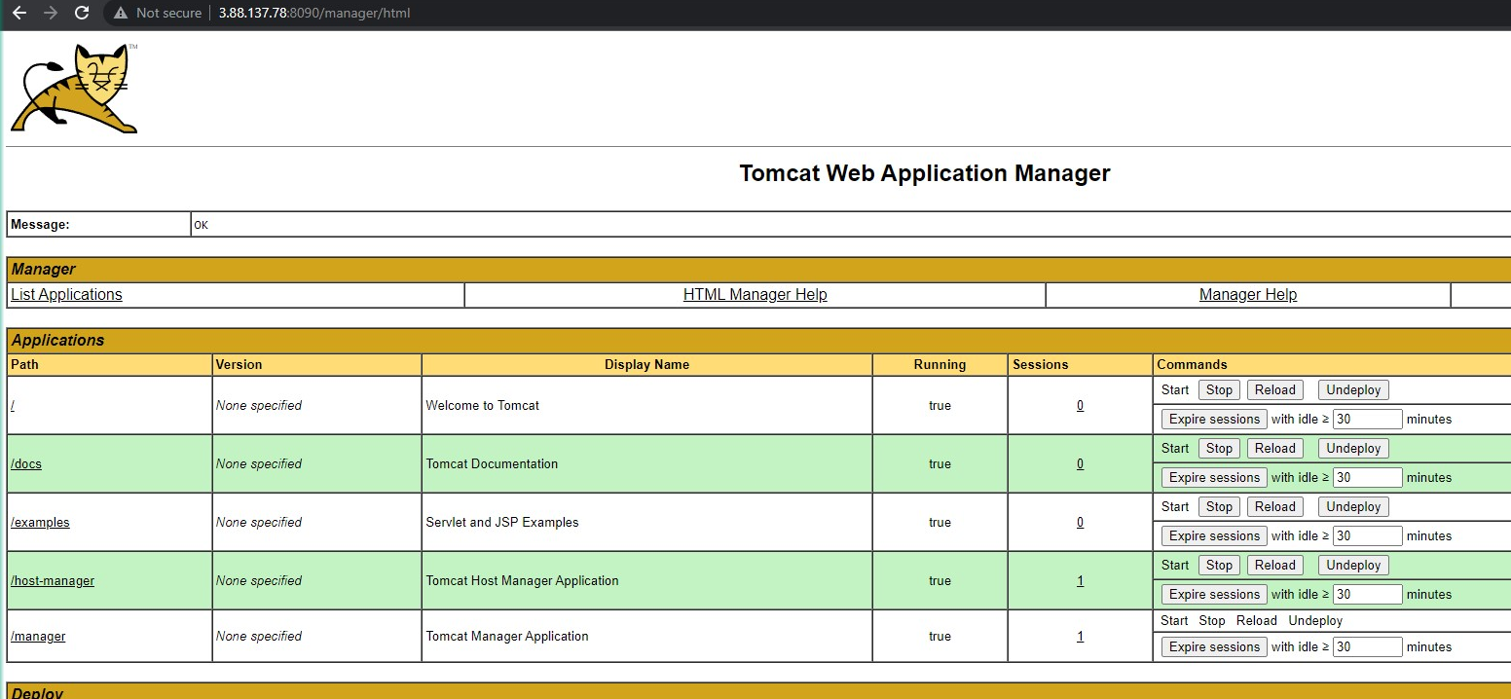

1. Go to Jenkins Webserver
2. Click on New Item – Click on Maven
3. Go to Manage Jenkins – Go to Global Configuration tools – Selected maven installations
4. Selected Version – 3.8.6 which you have installed in node and save
5. Created New Item Hello-World and selected Maven Project
6. Selected Git Under Source Code Management and copied URL from GIT HUB
7. Selected POLL SCM In BUILD TRIGGERS and provided shedule for CONTINUOUS INTERGRATION AND CONTINUOUS DEPLOYMENT
8. In Build by default POM.XML file available
9. Written clean install package in Goals and Options
10. In Post Build options if Deploy war/ear to a container is to be available first we need to install the Deploy to container available in Plugin Manager
11. Then went to post build options and selected **Deploy war/ear to a container in that by default i have provided **/*.war**
12. **Then i have created credintials and provided with user name and password which i have created deployer user in Tomcat**
13. **Selected that credintials**
14. **Copied tomcat URL**

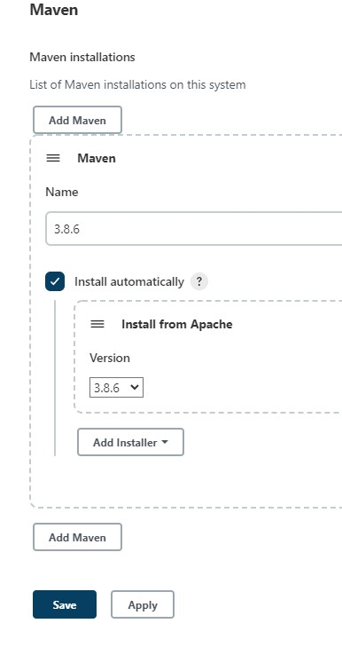

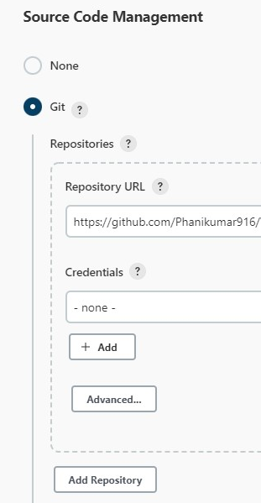

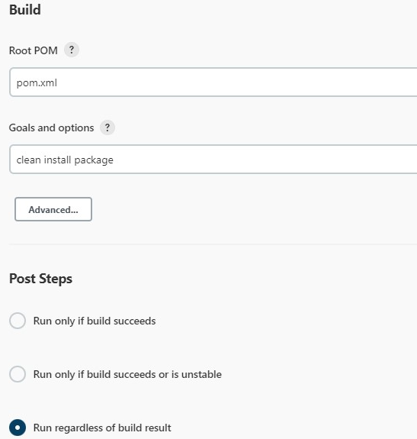

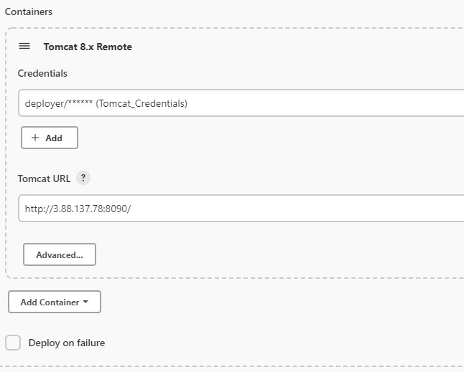

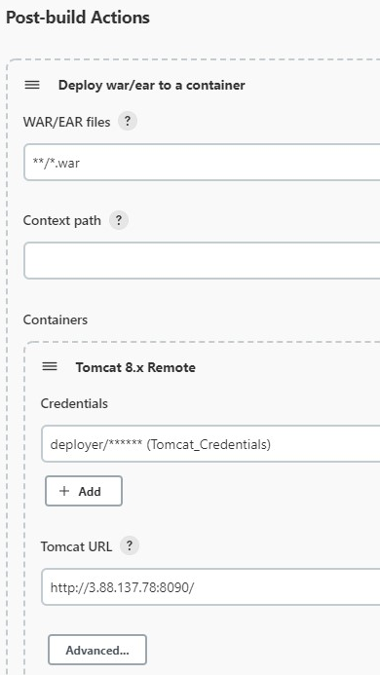

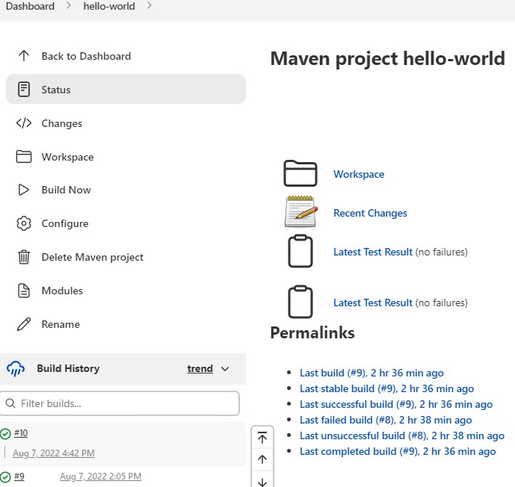



When i am changing the code in github it will automatically building and executing.